The Twist
December 2000

A Monthly Newsletter Publication of the Texas Twisters.

An associate member of the International Association of Gay and Lesbian Country / Western Dance Clubs.

(www.IAGLCWDC.com)
Texas Twisters
P.O. Box 192315
Dallas, TX 75219-2315
www.texastwisters.org / board@texastwisters.org / 972-993-2024 x1463
Website Gets A Makeover

Have you visited the Texas Twisters website lately? If you haven’t then you should surf on by and take a peek. The site has undergone something of a makeover. Just before our first performance at the Rodeo in Ft. worth, Dave handed off the webmaster duties to me, your brand new but ever so humble and demure webmaster: Tony a.k.a. CowboyDancer.
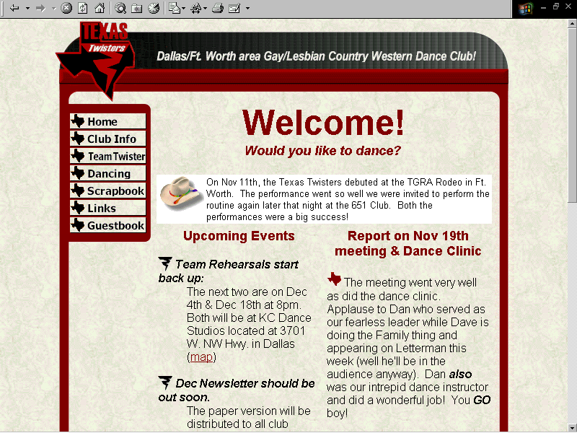
Just so everyone knows that this “ain’t my first rodeo” I thought I’d tell you a bit about my web background. I’ve acquired quite a bit of experience working with web pages through my professional responsibilities as a Systems Librarian. I’m also an instructor with Amigos Library Services contracted to teach website design and HTML encoding to librarians across the state. I presented a session on website design at the Texas State Library Association convention last year that went so well that they’ve invited me back to conduct an all day workshop on the same topic this coming April.
Since becoming the Twisters webmaster, I’ve been busy creating a base set of graphic elements all designed to create a sense of “place,” giving our website a clearly defined look. The design elements were created drawing heavily on those design elements present in our club logo. The base colors red, black and white are used throughout the site. Also, the twister and the Texas silhouettes have both been incorporated into the site design as bullets and as Java activated buttons. A neutral tan leather background balances the bolder colors and the logo and club description serve both as title and a graphic anchor on each page.
There are several sections to the site and a very good outline is in place indicating the type and scope of the information that will eventually be on the site. That information, including dance sheets, info on lessons and dancing in the DFW area, club info, archived newsletters, web links, a calendar of events and more, will be filled in gradually over the next couple weeks…which is where I need the help of my fellow Twisters:

1. If you have photos of our Ft. Worth performance or of any of our rehearsals or of the Halloween party, then please let me borrow them long enough so that I can scan some of them for the website.

2. If you wish to have your email or website listed on the links page then contact me.

3. If you have suggestions or comments about what you would like to see on the site then contact me.

The website address is: www.texastwisters.org
and my email is: cowboydancer@
texastwisters.org

Keep Twistin’
– Tony

Notes From The Chair
We're Movin' On Up
by Dave Hayes
Texas Twisters Chair
Our first performance was very well received at the Texas Gay Rodeo. So well received that we were asked to give a repeat performance at the 651 Fort Worth later that night.
I would like to thank several people for the success we've had so far. First, I would like to thank the dance team. You all have worked hard to make our first performance successful and your professionalism and commitment have been outstanding (even you, Dan).
Second, I would like to thank Rowdy. Rowdy has been there from the beginning, providing us with a place to rehearse and the education to raise our performance standard. I would also like to thank KC Dance Studios for allowing us to rehearse at a low cost. We appreciate how you have opened up your business to help us get our start.
Thanks to Carol and the staff at the 651. You have also been there from the beginning, immediately ready to provide support to our cause. Thanks also to the Roundup Saloon, where Texas Twisters got our start. We really appreciate what you have done and hope to be able to give back to you over the next few years.
It has been a long road--organizing the group, putting together bylaws, starting a performance team, getting costumes--but all in all it has been FUN for me. I do think that everyone else on the team has had fun as well. And there is more fun to come.
These performances have sparked an interest in members of the country dance community. We have had several inquiries about how to join the club and how to be a part of the team. Everyone should know that no matter what your dancing ability, you can be a Texas Twister. We will be looking for all people interested to become a part of our group and / or our team.
We have what I believe are some really obtainable goals for the next year, including the following:
- Raising our general membership to 50 members.
- Building a stronger, larger dance performance team.
- Building a competition team to compete and perform in Fort Lauderdale, FL.
- Havin fundraisers and social outings, which will give us a chance to do something outside of the bar environment (although we do want to have group gatherings at the bars, as well).

I believe if we work hard and think positively, we can succeed with all of these goals.
Another personal goal I have is not only to be able to host a local dance event, but to bid for an Annual or Semi-Annual convention of the IAGLCWDC (International Association of Gay and Lesbian Country / Western Dance Clubs). These conventions draw people from all over the world, people who are really serious about country music and dance. Having an annual convention here would be a chance to host a dance competition, a great opportunity for Dallas / Ft. Worth dancers to show off their talents and compete with people from around the world.
With all this in mind, if you are not yet a member of Texas Twisters, we would love for you to check us out. You are welcome to attend any of our rehearsals, as well as any dance clinics we hold. The dance clinics are separate from the regular dance classes you might normally attend. They are geared to bring in dance styles and line dances that the local community has not seen or done before.
If you are a member now, I am glad you are here. It is with you that we will continue to be successful.

And Now for Something Completely Different...
By Dan Sigale
Co-Chair
The performance team did really well at the rodeo, and I think I speak for everyone when I say that we all had a good time doing the routine.
Now, we're going to forget about it. For now, anyway.
Not content to rest on our laurels, we are going to start learning a new routine on Monday, December 4 (see calendar for details). This routine will be COMPLETELY different from the one we just did--instead of a couples’ dance
routine, we will be doing a line-dance routine.
I know that some people prefer the couples dance format over the line dance format. I also know that some people prefer the line dance format, and either did not participate in the couples dance routine that we just performed or did so begrudgingly. Obviously, we can't please all the people all of the time, so the idea is to vary the routines as much as possible, thereby at least pleasing some of the people some of the time.
In addition, we are planning on entering the team line dance competition during a hoe-down in Fort Worth the weekend of March 21-24. This will be our first competition, and it will be a great opportunity to get our feet wet before heading down to compete at the SunDance Hoe-down in Fort Lauderdale.
Finally, when the team does perform in Fort Lauderdale next May, we can enter in several team categories, two of which are couples and line dance. Our goal is to perform in AT LEAST these two categories, so we need to start working on various types of routines immediately.
For those of you who are not big line dance fans, give this routine a try, anyway--Rowdy (our dance coach) has choreographed a great routine that he is excited to share with the team. If you try it out and still can't get into
it, don't worry, because we will be doing more couples routines in the near future.
I want to encourage EVERYONE (even new and interested dancers) to come to the first rehearsal on Dec. 4. Now that we've gotten our first routine learned and performed, it should be even more fun and exciting to start working on the
second
DECEMBER 2000
Sunday | Monday | Tuesday | Wednesday | Thursday | Friday | Saturday
 |  |  |  |  | 12/1 | 12/2
12/3 | 12/4 | 12/5 | 12/6 | 12/7 | 12/8 | 12/9
 | 8pm - KC Dance
 | Dance Team
 | Rehearsal
12/10 | 12/11 | 12/12 | 12/13 | 12/14 | 12/15 | 12/16
 | 8pm - KC Dance
 | Dance Team
 | Rehearsal
12/17 | 12/18 | 12/19 | 12/20 | 12/21 | 12/22 | 12/23
PERFORMANCE | 8pm - KC Dance |  |  |  | Chanukah Begins
@ the Roundup | Dance Team |  |  |  | at Sundown
Hard Candy Christmas Show | Rehearsal
12/24 | 12/25 | 12/26 | 12/27 | 12/28 | 12/29 | 12/30
 | Christmas Day
12/31
New Year's Eve
Directions to KC Dance Studio and to the 651 Fort Worth, and to the Roundup are available at the Texas Twisters website (www.texastwisters.org).
Everyone is welcome to come to the rehearsals, not just those on the dance team.
Please note that this is a slow month for Twister events due to holidays. Next month we have a lot more planned already.

